Service nodePort
deployment.yaml
apiVersion: apps/v1
kind: Deployment
metadata:
labels:
app: app
name: app
spec:
replicas: 2
selector:
matchLabels:
app: app
strategy: {}
template:
metadata:
labels:
app: app
spec:
containers:
- image: nginx
name: nginx
ports:
- containerPort: 80
kubectl -f apply deployment.yaml
kubectl get pod -o wide
kubectl get deployment <deployment-name>
app
create service NodePort file svc.yaml
apiVersion: v1
kind: Service
metadata:
name: app-service
spec:
type: NodePort
selector:
app: app
ports:
- protocol: TCP
port: 80 # Port that the service will expose
targetPort: 80 # Port on the container (nginx in your case)
nodePort: 30007
kubectl apply -f svc.yaml
kubectl get service -o wide
kubectl get pod -o wide
------------------------------------------------------------------------------------------------
Run the service on local host
kubectl exec -it pod -- curl http://localhost
check the security group of relevent working node update the Custom TCP rule ex 30007
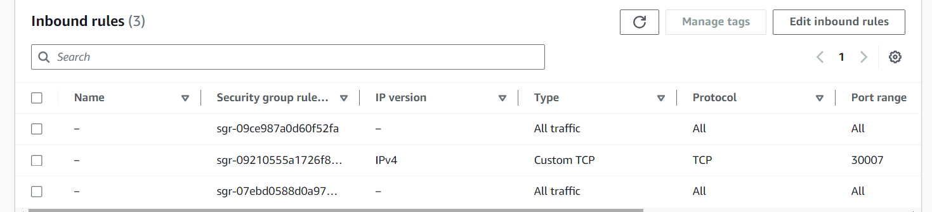
hit publicIP:nodeport on web
ex - http://65.2.37.118:30007/

